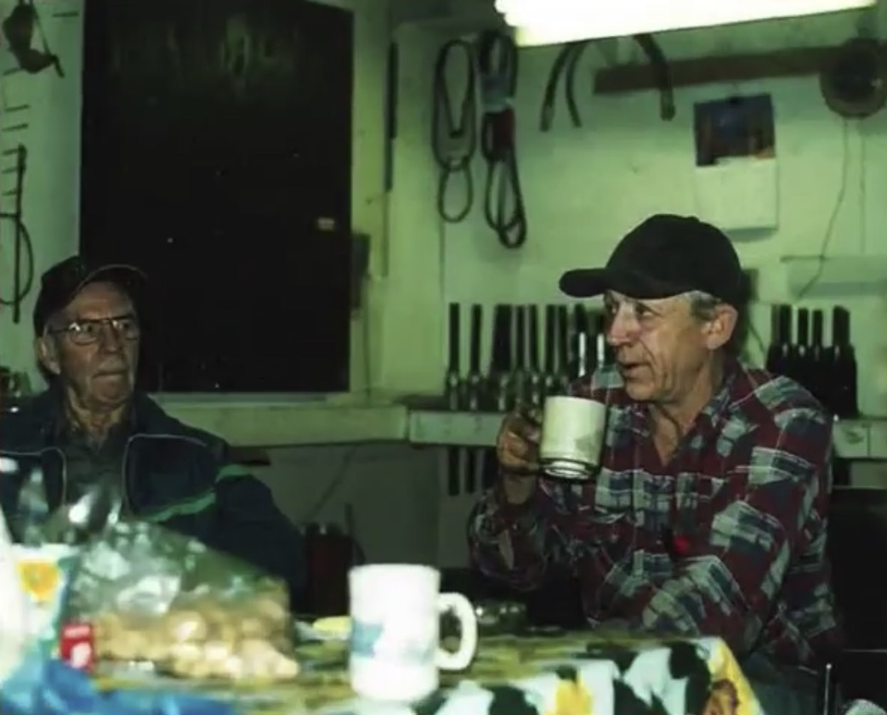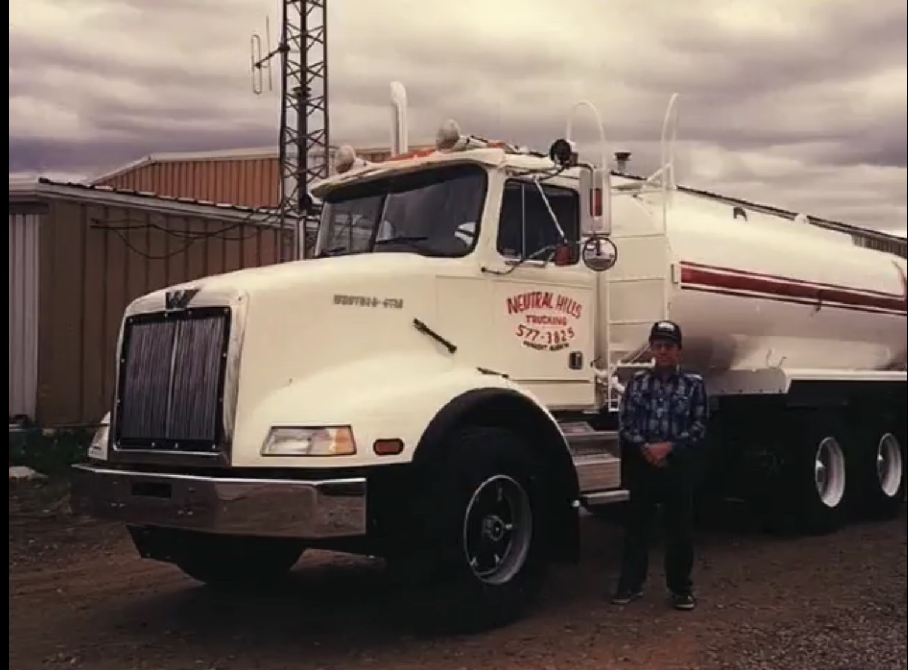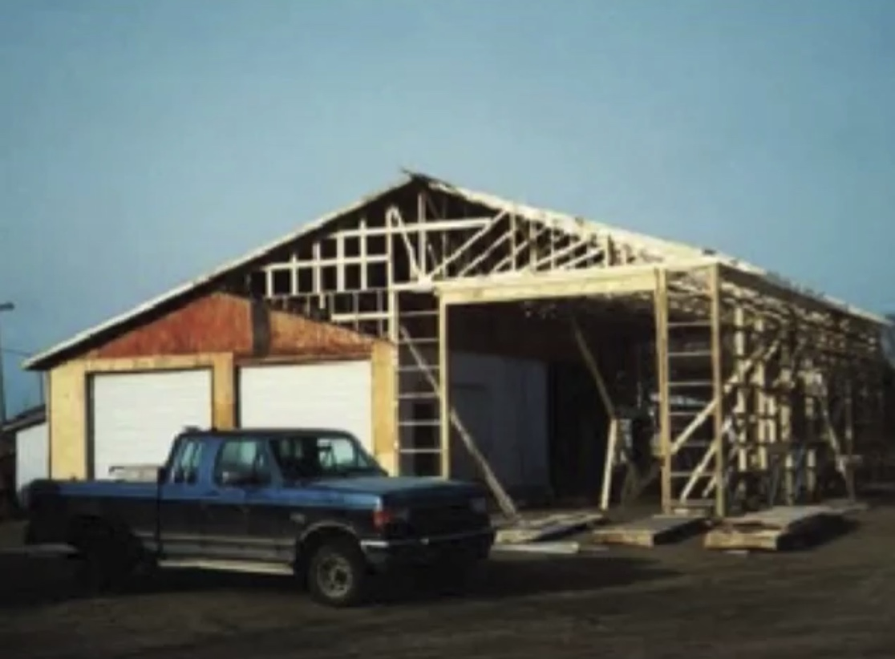

Although we now have dealers, it is still important for us to maintain contact with end users and make sure that they are getting what they need. Anyone can walk into our shop and buy a pump. And dealers are required to provide the same price we do and advise clients that our pumps can be repaired and have core credit value. We have a repair shop where pumps are brought in daily either on or off the truck for complete repair. Once repaired, they perform like new, with all of the worn components being replaced. Reusable parts are cleaned up and reused, saving the customer money and reducing waste. Our new pump installations are done in a streamlined fashion, allowing easy access to the pump for repair or maintenance. As we understand the importance of down time, our services are all completed in the timeliest possible way, often with three or more guys working to get you on the road quickly. Environmental impact continues to be paramount in our business and we endeavour to reduce our footprint as much as possible. Almost every part put into a T&E can be recycled. We actively recycle everything from steel to paper, bronze to batteries, in our shop. Anything that can be purchased locally is, and if we can’t get it in Consort-the village where we are based.

Ted passed away in February 2016, but T&E continues on with his wife Elaine, and daughters Rachel & Erica at the helm and the 26 staff that keep the business rolling. Nothing in our business is more important to us than the quality of our product, our relationship with our clientele, and our staff, who are like family. It is our distinct pleasure to work with truckers to keep the fluid moving.

We look forward to working with you!

T&E Pumps is a perfect example of ingenuity born of necessity, of perseverance, and the entrepreneurial spirit evident in many oil boomtowns. Ted Devine established T&E Pumps Ltd. in 1999, after 24 years in the patch. For 15 years he owned and operated tank trucks specializing in infield hauling. In all those years there were daily struggles with poor suction, leaking pumps, pumps that couldn’t be repaired, waste, pumps that were worth nothing after a couple weeks and poor performance after the initial new wore off. Coupling this with the Alberta oil patch becoming increasingly aware of its environmental impact drove Ted to fix these problems. T&E manufactures the most reliable, longest lasting pumps on the market, as well as the most environmentally friendly.

The first prototypes of T&E were put onto trucks other than his in about 1998. By 2001 the patent had been granted, and the trickiest part became figuring out how to manufacture the parts required on a larger scale. Many of the parts that were needed were either unavailable or too costly to produce on a small scale. Thus the manufacturing facility that we now have where most of our manufacturing is done was born. The expertise of local machinist Neil Polson (Consort Machine Shop) was heavily relied upon. Neil was instrumental in helping Ted with the creation of our helical cut gear, as well as the perfection of many of the other parts in our pump. Selling the product was a different story. With the market already flooded with other pumps, no retailers wanted to touch a T&E Pump, so he sold it himself. The most important thing for Ted was making sure that the truckers who wanted a T&E could get a T&E and that they weren’t being taken advantage of by a middleman.

**T&E**

**History**